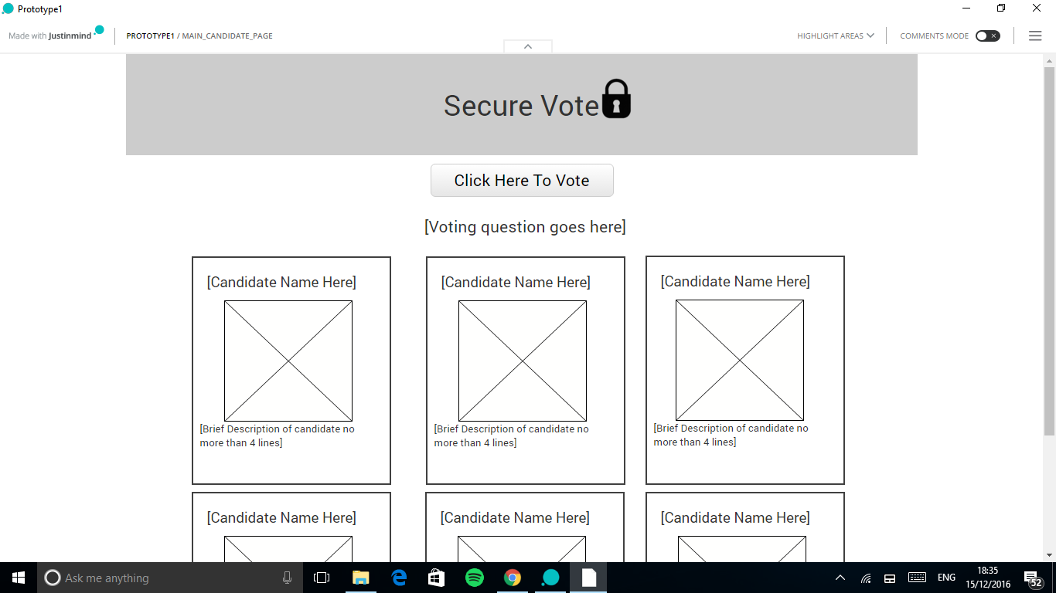

This is the main page, ,click on the click here to vote page and the user is taken to the user login page.

Use PHP commands to get the voting question , this should work once we get the databases made!!!.......

<?php

$con = mysqli_connect("csmysql.cs.cf.ac.uk","(usernameWEDONT KNOW THIS YET )","passwordWEDONT KNOW THIS YET","database name WE DONT KNOW THIS YET");

if(!$con){

die("Cant connect: " . mysql_error());

}

$query = "SELECT * FROM CURRENTVOTE";

$result = mysqli_query($con,$query);

while($row = mysqli_fetch_assoc($result)){

echo $row["VotingQuestion"]

?>

To get the candidates we will use PHP again, as the databases havent been made its tricky, just try make one sample candidate, to get them all we will copy the format of the one you make and use a php command to list them all.

When the image of the candidate is clicked on it takes them to a page which displays more information on the candidate…

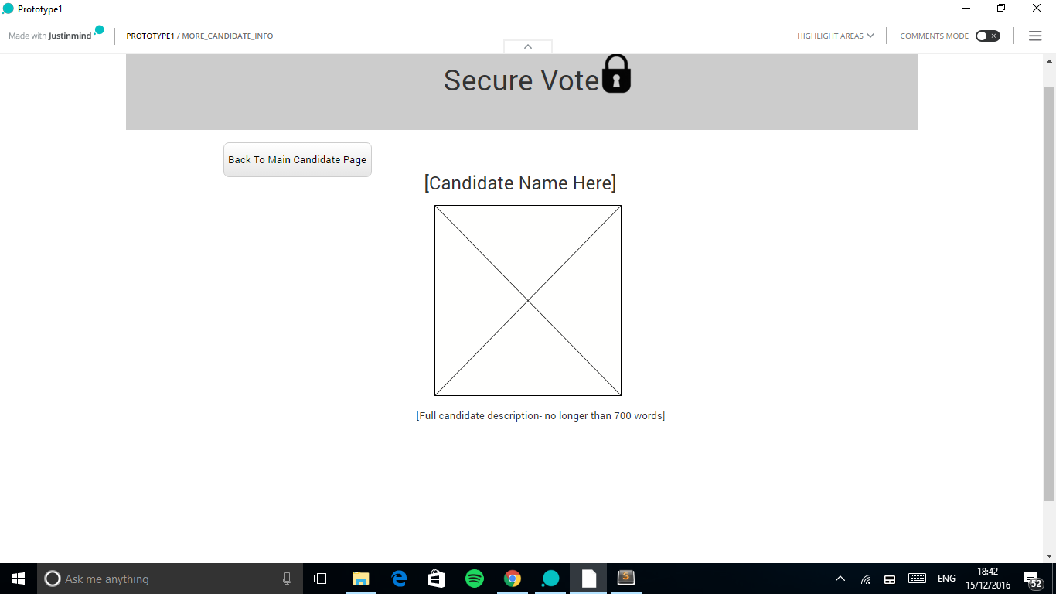

We will send the candidate name using the GET method,

User login(ive made this already)

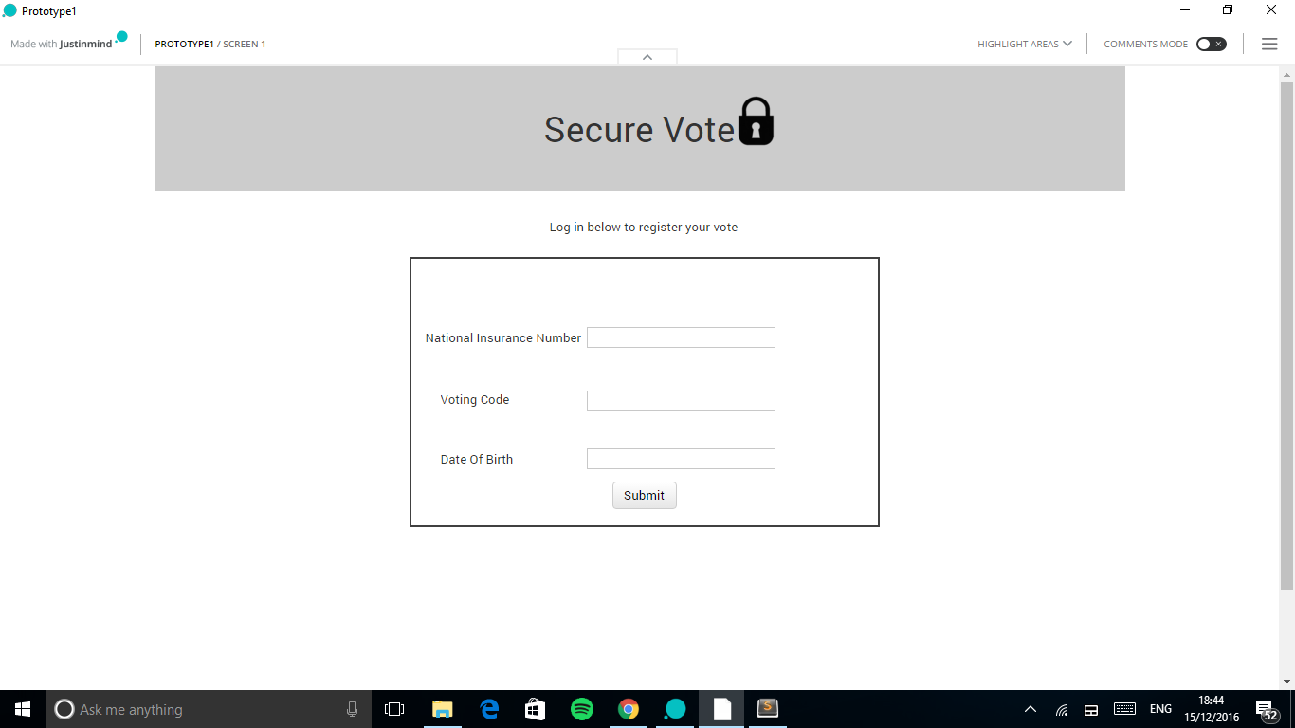

Admin login (ive made this already)

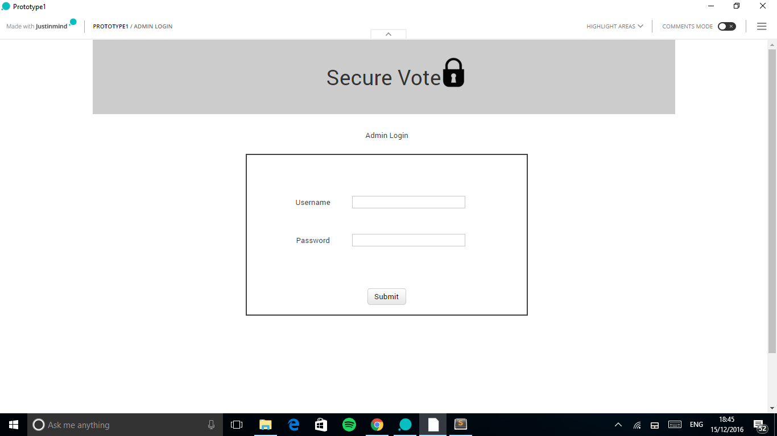

Admin homepage (ive made this already)

